## Configure Visio (QRC)

## Introduction

The Configure Visio QRC shows how to set up the optimal configuration to utilize the ExxonMobil Framework Visio Stencils and Templates on ExxonMobil PCs and storing the artifacts on the EMAF Architecture Repository.

## Configure Visio Instructions

### Create **My Shapes** & **My Templates** Folders

From File Explorer, navigate to your network account **c:\users\<your network id>\LocalData** folder, and create 2 new folders called **My Shapes** and **My Templates**

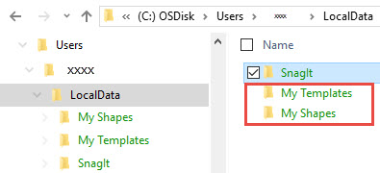

### To configure Visio to use **My Shapes** & **My Templates** Folders

1. In Visio, click the **File** Menu

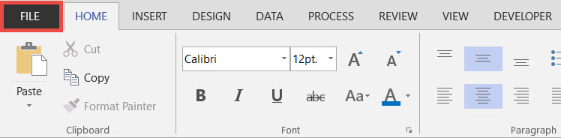

1. Click the **Options** Sub-menu

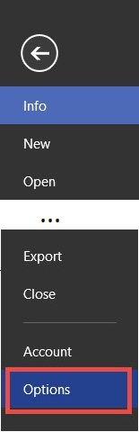

1. Once the Visio Option dialog box is displayed, click the **Advanced** option

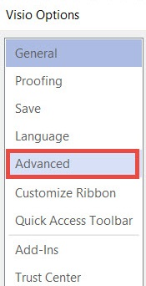

1. Scroll to the bottom of the Advanced options, click the ***File Locations...*** button

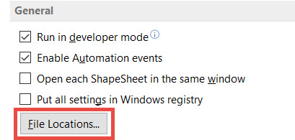

1. Configure the **My Shapes** & **Templates** Folders

* Click the ellipses button "**...**" for **My Shapes**, then set the path to your **localdata\My Shapes** folder
* Click the ellipses button "**...**" for **Templates**, then set the path to your **localdata\My Templates** folder
* Click the ellipses button "**...**" for Drawings, the set the path the EMAF Architecture Repository: <https://ishareteam4.na.xom.com/sites/Architect/Architecture%20Repository>
* Click the **OK** button

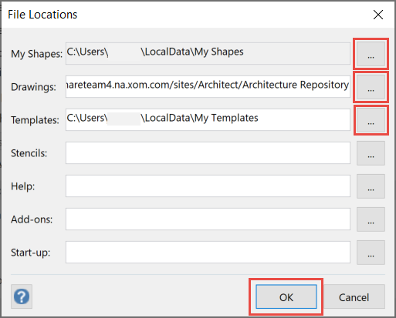

**NOTE: When you attempt to perform an open or save as to a Visio diagram, the file dialog will default to the EMAF Architecture Repository**

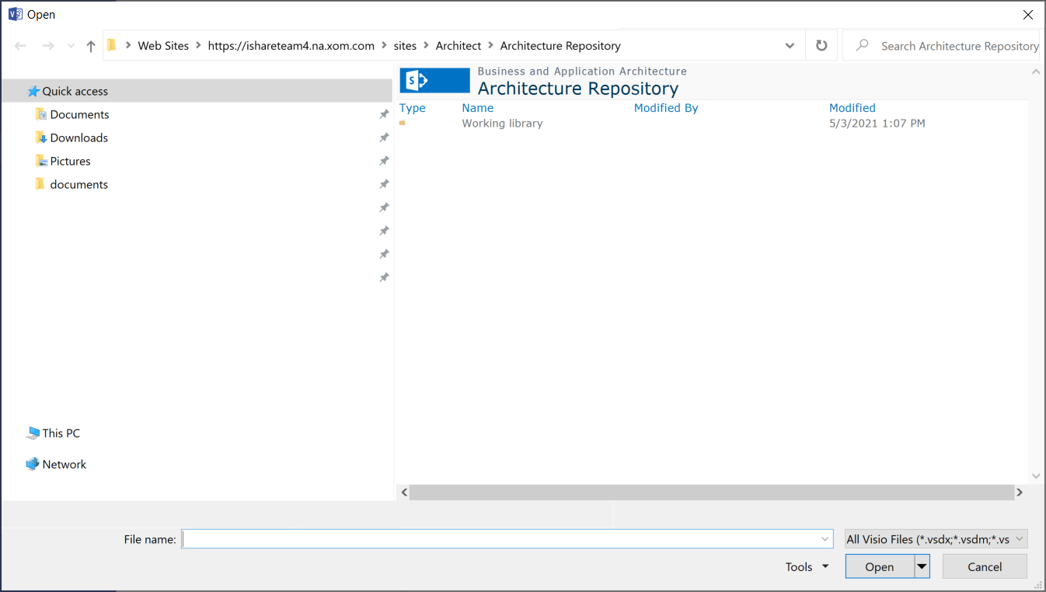

### To pin other EMAF Architecture Repository Targets

Once you have begun opening or saving Visio diagrams to folders in the EMAF Architecture Repository, these folders will begin appear under your Recent Folders area which you can then pin these locations for a quick and convenient way to access these locations in the future.

1. In Visio, click the **File** Menu



1. Click either the **Open** or **Save As** Sub-menu, click **SharePoint**, then under the **Recent Folder** area select the SharePoint location and click the **Pin** icon

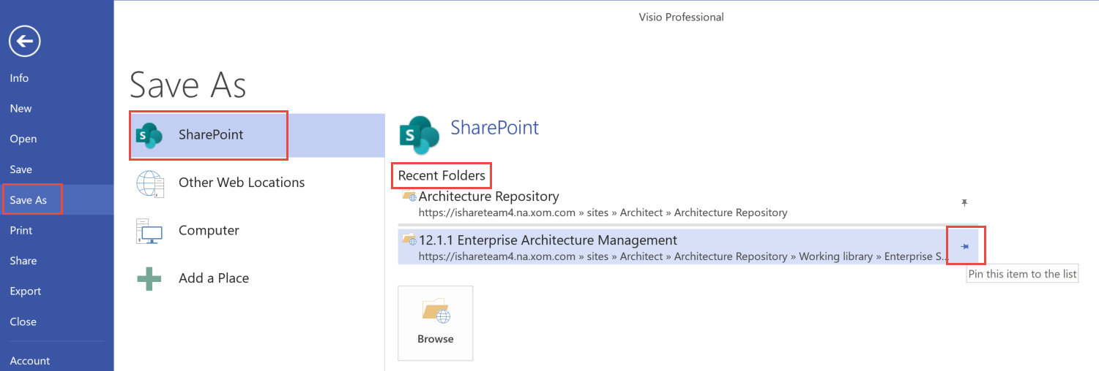

1. To use the pinned locations, simply click the location you want to open the Open or Save As dialog box

